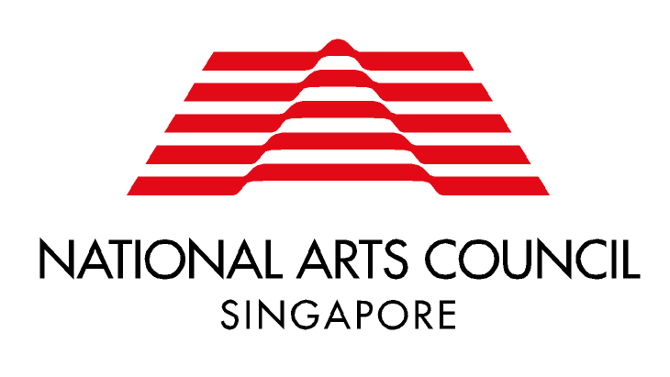

Market and Audience Development Grant Self-Evaluation Report

Date of Submission
Applicant Name | Project Title
Venue/ Cities  (if applicable) | Event Dates Start  (if applicable) End

When your project is completed, we would like you to share your evaluation and reflections on your project with us. You may wish to use the following questions as a guide.

Where available, please attach any:
- Photos / recordings
- Media clippings / press reviews

For Company-wide Initiatives (e.g. branding, marketing and publicity, market research)
- What were your objectives in undertaking this project, and how would you evaluate your outcomes?

For Project-specific Initiatives (e.g. marketing and publicity for a specific production / exhibition)
If applicable / available | Actual
Number of Performances / Exhibition Days
Total Attendance
Number of Tickets Sold
Percentage House

- Has your audience attendance / sales grown compared to previous projects?
- Were your initiatives effective in marketing and audience development? What worked and what didn’t? What could be done better?

For International Activities
If applicable / available | Actual
Number of cities visited
Number of performances
Total attendance
Number of tickets sold
Percentage house
Number of Digital Audiences/ Digital Interactions at the point of report submission (if applicable)
For e.g. audiences who watched the presentation of the arts and technology project, number of online streaming audiences, downloads of an application accompanying the presentation, views of a virtual exhibition or performance etc

- How was the audience response to your project?
- How has this project benefitted you (e.g. increased your international profile, created new opportunities)?

Feedback on the Grant:
- Are there any areas in which NAC can do better to support your market and audience development efforts?

For grants applied through the MCCY Grants Portal (now rebranded to OurSG Grants Portal)

Please log onto the OurSG Grants Portal to submit your Self-Evaluation Report and Financial Report (i.e. the budget form submitted as part of the grant application, with actual income and expenditure reflected). To help you navigate the portal, you may refer to the user guide uploaded at https://go.gov.sg/nacmadgrant.

For grants applied through the Market and Audience Development Grant Mailbox

Please email your Self-Evaluation Report and Financial Report (i.e. the budget form submitted as part of the grant application, with actual income and expenditure reflected) to the Manager in charge of your application (please refer to your Letter of Offer) or to nac_marketaudiencedevt_grant@nac.gov.sg and indicate “EVAL: Your Project Name” in your email subject title.

