Special Education Artist-in-School Scheme (SPED-AISS) 2024 – Annex 1
Please submit your application through FormSG here: https://go.gov.sg/sped-aiss-2024

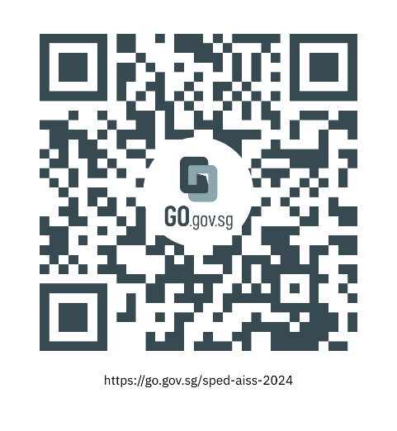

Complete the online application in one sitting. Please ensure that you have the following information ready.

o SPED-AISS Project Proposal, comprising:
- School Applicant Details (school name, teacher-in-charge, contact details etc.)
- Project Summary (project title, objective, art form etc.)
- Schedule (start and end dates, number of contact hours etc.)

o SPED-AISS Annex 1 template (this document), comprising:
- Programme Outline
- Project Details
- Budget
- Artist(s) CV

Note: FormSG has a 7MB limit for attachments, so please ensure that all files are formatted to fit into a single document.
Part 1/4: Programme Outline Template
Instructions
- Take time to read the SPED-AISS 2024 Grant Guidelines on the AISS website to gain a better understanding of the scheme, including funding details, qualifying criteria and application process. A well-written programme outline helps NAC envision your project.

- Ensure that the programme outline articulates learning strategies/activities that build towards the project’s intended learning outcomes. This template should be submitted by the teacher in-charge, in consultation with the arts professional. Avoid submitting generic lesson plans prepared by the artist/ arts group; the programme should be customised to the target profile’s learning needs.

- Note that SPED-AISS projects should not replicate existing NAC-Arts Education Programme (NAC-AEP) on the Directory. SPED-AISS supports projects with unique / customised objectives and content to meet the specific needs of the school that cannot be fulfilled by purchasing an NAC-AEP.

School Name:

Project Title:

Name of Artist/ Arts Group:
Intended Learning Outcomes:
By the end of the project, students will be able to…

1)
2)
3)

Describe the project structure and how it seeks to achieve the intended outcomes:

Details of Sessions (Students): Please indicate breakdown in the table below, taking reference from the example provided

No. | Target Profile* (indicate breakdown) | No. of Students | Number of Sessions (total and breakdown) | Length of Each Session | Frequency of Sessions | Project Period | Remarks (optional)
E.g. | 3 classes of Year 3 Art Students | 25 | 20 sessions total  6 sessions x 3 classes, followed by 2 combined sessions. | 50 min | Weekly (with exception of school/ public holidays and weighted assessment weeks) | Feb – June 2023 | The three classes will have separate sessions until the last two sessions, which are combined for a gallery walk/ showcase component.
1
2
3

*Target Profile examples include Interest Groups, CCAs.

Session No. & Focus | Description of Activities  Provide a detailed description of the strategies and activities in each session. NAC will be assessing the proposal on teaching strategies and how the lessons are scaffolded and tailored to the specific student profile. You may want to also state the resources, materials or tools that will be used.  Add rows below as needed. Do not attach other documents in place of this template.
E.g.  1: An Introduction to Singapore Literature | E.g.  Introduction:  - Students will be introduced to a timeline of local literature beginning from 1965. [Lesson objective] The artist will be using Powerpoint slides to guide the lesson and will be facilitating a quick quiz to activate students’ prior knowledge. [Strategy]  - Students will then be divided into groups to co-write a short local poem according to the assigned themes. Students who are comfortable with writing can choose to explore writing in different languages, whilst students who have less confidence can start with prompts using the writer’s previous works as a starting point… [Demonstrate tailoring to various student needs].  - Exit pass: all students are to share one word which describes their learning experience in this lesson.

For projects with teacher-training components only (optional for SPED-AISS Objectives 1 and 2)
Description of teacher training objectives:
1)
2)
3)

Description of teacher training plan:
Provide (a) the number of sessions, b) a description of the topics and/or activities to be covered, and (c) how it seeks to achieve the intended outcomes.
You may want to also state the resources, materials or tools that will be used.

Number of Sessions (Teachers – for projects with teacher-training components only):

Name of teacher(s) participating in this training | Designation

Part 2/4: Project Details
[For student-facing projects only] How is the lesson plan customised to the specific needs of the students?

How does the project align and contribute to the school’s learning outcomes?

How does the school plan to track and evaluate the project’s effectiveness in contributing to the learning outcomes?

Part 3/4: Budget Template
Please provide a clear breakdown of artist fees and material costs. NAC will assess if the items are supportable. Grant amount will be based on project merit and subject to funding caps. Schools may include a presentation/showcase component as a culmination of their SPED-AISS project, however stand-alone presentations/showcases will not be supported.
Guidelines for Material Costs
- The following material costs are not supported under SPED-AISS:
- Transportation
- Meals
- Equipment maintenance
- Installation costs
- Venue rental
- Assets (the list below is not exhaustive):
  - Equipment (E.g. kiln, iPad)
  - Software
  - Instruments

- Short-term rental can be considered for selected items such as instruments and artmaking equipment.

Manpower costs (e.g. artist, assistant facilitator, choreographer) |  | Artist fees per hour | No. of contact hours |  | Total cost
Total manpower costs
Material costs  (visual arts materials – E.g. clay, sculpting tools, costumes, rental of instruments and equipment) | Unit Price |  | Quantity | Total cost
Total material costs
Total SPED-AISS Project Cost (Manpower costs + Material costs)

Part 4/4: Artist(s) CV Template
- Please adhere to the template provided and limit this portion to a maximum of one full page per artist/ instructor. Attaching other documents (E.g. CVs, resumes) in place of this template will render the submission invalid.
- Note that only local artists, or artists currently engaged by a local company with the relevant work passes, will be considered. Please refer to the Grant Guidelines document for further details on assessment.
Biographical information  - Name  - Contact details  - Company (if relevant)  - Artist Statement (optional)  Note: Do not include NRIC or other sensitive personal information. | Professional/ educational qualifications (E.g. certifications, diplomas, proof of mentorship or apprenticeship etc.) in the relevant art form | Track record of relevant local/ international industry experiences  Do indicate if the artist is currently conducting NAC-AEP and state the organisation(s) which have engaged them. | Track record of pedagogical qualifications/ training/ experience relating to the student profile involved in the project.
 | Please indicate the year of attainment.  1)  2)  3) | No. of active years in industry:  Please list key engagements and the year they were conducted: | Pedagogical qualifications / training:  Please indicate the year of attainment.  1)  2)  3)  No. of active years teaching in SPED schools:  Please list key engagements and the year they were conducted:

Examples of professional/ educational qualifications: ABRSM Diploma, La Salle or NAFA certification, degree in the relevant art form (educational/ pedagogical certifications should not be listed here)
Examples of local/ international industry experiences: public performances/ showcases (E.g. at festivals or shows), published work, represented Singapore in competitions/ performances on the international stage etc.
Examples of pedagogical qualifications/ training/ experience: SSI / RCTC’s En Route to Inclusivity, Diploma/ Bachelor’s in Special Education (please state institution), current lecturer at an institution etc.

